Project Design Document
Milestone 3
Java Desktop Application using Swing UI and JDBC
Document detail | Information
Project title | Exam Seat Arrangement System (Smart Exam Seating Arrangement System)
Team number | ____________
Class and semester | S3
Course | Java Programming
Milestone marks | 3 Marks
Submission date | ____ / ____ / 2026
Submitted by | Antony Zavior K (Team Lead, Roll 62); Lijo P Thomas (Roll 67); Milind Krishnan (Roll 69)

This document converts the approved project requirements into an implementable design. Each diagram, class, table, screen and design decision is traceable to one or more functional requirements (FR-01 to FR-08).

Document control and team details
Version | Date | Prepared by | Changes | Status
0.1 | ____ | Team | Initial design submission, aligned with the implemented application | Draft

Team and HackerRank Java progress
No. | Student | Roll no. | Role | HackerRank profile | M2 stars | Current stars | Change
1 | Antony Zavior K | 62 | Team Lead | hackerrank.com/profile/haxey61790 | 5 | 5 | 0
2 | Lijo P Thomas | 67 | Member | hackerrank.com/profile/lijot707 | 5 | 5 | 0
3 | Milind Krishnan | 69 | Member | (add profile link) | — | — | —

Evidence: working profile links are given above; add a current screenshot per member in Appendix A. Stars must be re-checked on the review date.

1 Design basis
The Exam Seat Arrangement System is a Java Swing desktop application that uses JDBC and MySQL to generate clash-free exam seating plans. The exam coordinator enters rooms, exams and students; the system selects students for an exam, shuffles them (including department mixing), assigns them to room, row and column positions, stores the plan in one transaction and presents room charts, seat search, attendance sheets and printable reports.
The design approach is a layered MVC-style architecture: Swing screens (ui) call services (service) or DAOs (dao); DAOs use JDBC PreparedStatements to read and write the database and return plain model objects (model).

1.1 Requirements changes
Change ID | Requirement | Change and reason | Approved by
DC-01 | FR-03 | CSV import of student lists is not implemented; students are entered through the Student screen. Moved to future enhancements. | Pending faculty
DC-02 | FR-06 | Room chart is read-only; manual seat swap is moved to future enhancements. Seats can be regenerated with a different shuffle instead. | Pending faculty
DC-03 | FR-02 | Rooms are modelled with rows and columns (capacity = rows x columns); a separate seats-per-bench field is not used. | Pending faculty
DC-04 | FR-05 | Same-branch separation is achieved by the Department Mixing shuffle (round-robin across departments) together with eight other shuffle options. | Pending faculty
DC-05 | FR-01 | Passwords are currently stored as plain text in the users table; hashing is a future enhancement. | Pending faculty

1.2 System architecture
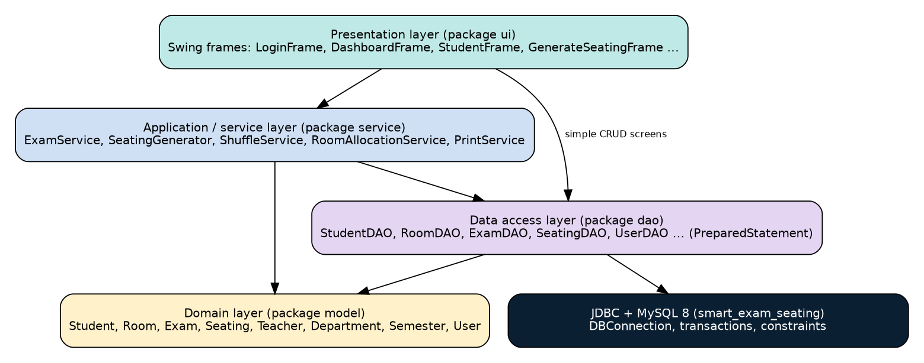
Figure 1 System architecture diagram (layered; arrows show permitted dependencies)
Layer | Responsibility | Key classes / packages | Depends on
Presentation | Swing screens, events and user messages | ui: LoginFrame, DashboardFrame, StudentFrame, GenerateSeatingFrame, SeatingResultFrame | Service, DAO, model
Application / Service | Coordinates use cases, shuffling, room allocation, printing | service: ExamService, SeatingGenerator, ShuffleService, RoomAllocationService, PrintService | DAO, model
Domain | Business entities | model: Student, Room, Exam, Seating, Teacher, Department, Semester, User | None
Data Access | Executes JDBC operations and maps records | dao: StudentDAO, RoomDAO, ExamDAO, SeatingDAO, UserDAO ... | JDBC, database

2 Use case design
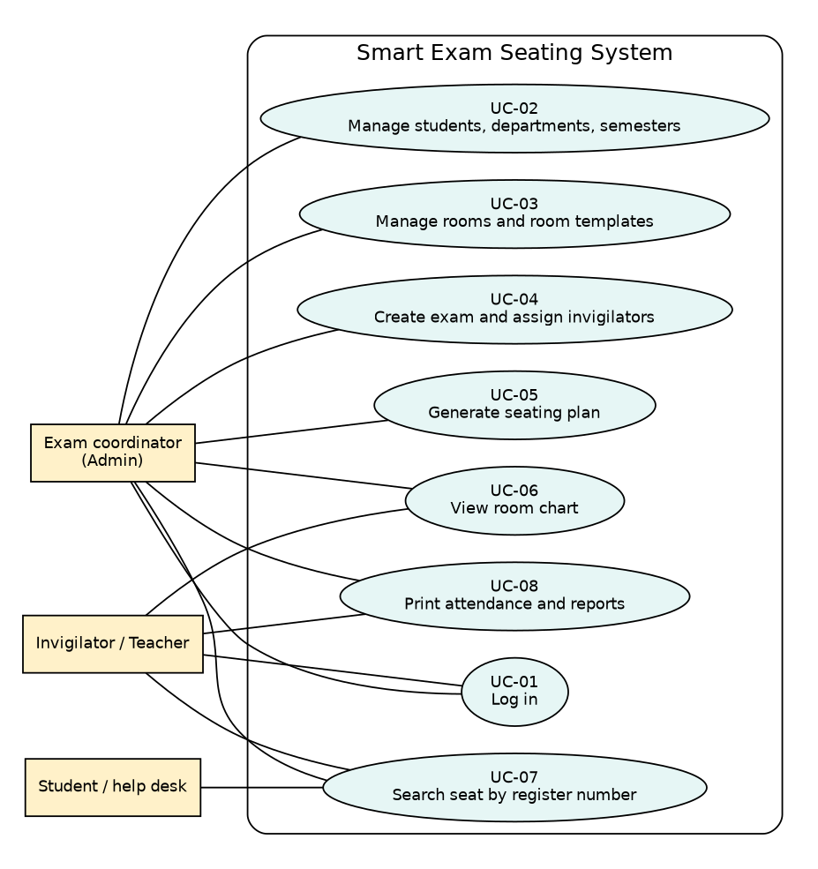
Figure 2 Use case diagram

2.1 Actor responsibilities
Actor | Description | Main use cases | Requirements
Exam coordinator (Admin) | Exam cell staff who prepare the plan | UC-01 to UC-08 | FR-01 to FR-08
Invigilator / Teacher | Staff who view charts and sheets; cannot change master data | UC-01, UC-06, UC-07, UC-08 | FR-01, FR-06, FR-07, FR-08
Student / help desk | Looks up hall and seat | UC-07 | FR-07

2.2 Detailed use case specification
Field | Details
Use case ID and name | UC-05 Generate seating plan
Primary actor | Exam coordinator (Admin)
Preconditions | Logged in; exam, students and rooms exist; students match the exam's departments and semesters
Trigger | Admin clicks Generate on the Generate Seating screen
Main flow | 1. Select exam, shuffle option and room mode. 2. System loads matching active students. 3. System selects rooms (automatic) or validates the chosen rooms. 4. System shuffles students and assigns room, row and column. 5. System saves all seats in one transaction. 6. Result screen shows room charts and summary.
Alternate or error flow | No students match: error message. Capacity too low: warning. Plan already exists: confirmation before regenerating. Database error: transaction rolled back and message shown.
Postconditions | Every selected student has exactly one seat for the exam; no seat is used twice
Related requirements | FR-04, FR-05, FR-06

Field | Details
Use case ID and name | UC-07 Search seat by register number
Primary actor | Student / help desk, Admin, Teacher
Preconditions | Seating has been generated for the exam
Trigger | User enters a register number and clicks Search
Main flow | 1. Enter register number. 2. System validates it. 3. System queries the saved seating. 4. Room, row and seat are shown and can be printed.
Alternate or error flow | Empty input: validation message. No seat found: 'not found' message. Database error: message dialog.
Postconditions | No data changed
Related requirements | FR-07

3 Class and object design
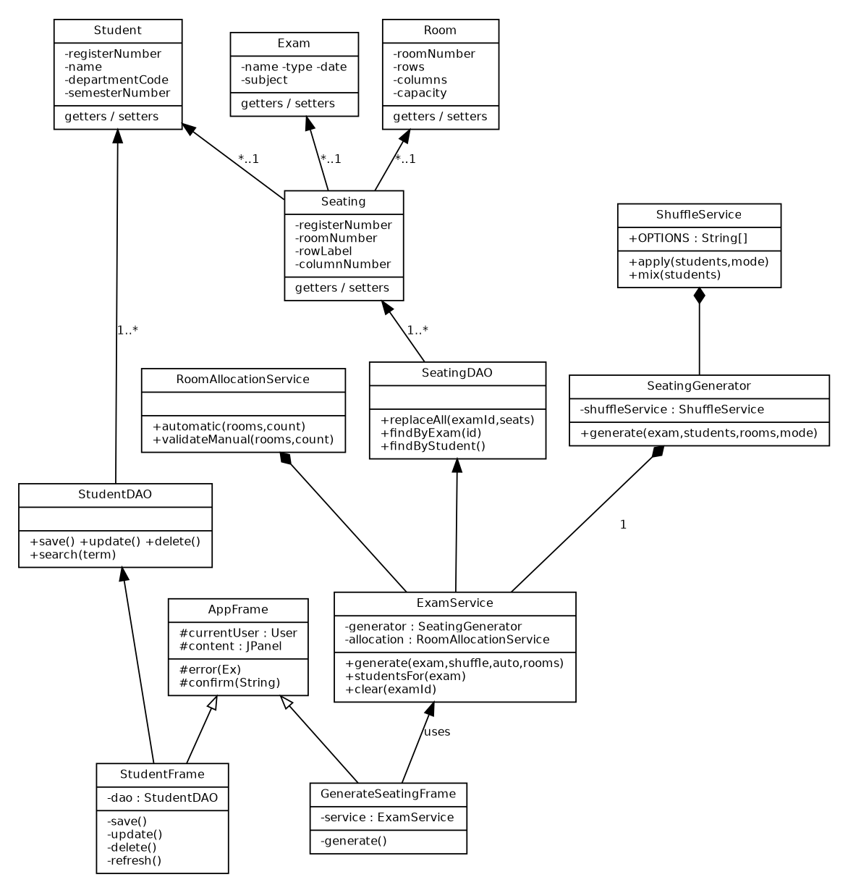
Figure 3 UML class diagram (key classes)

3.1 Class responsibilities
Class | Type | Responsibility | Key members | FRs
AppFrame | UI (abstract) | Base class for screens: holds logged-in user, common error and confirm helpers | currentUser, error(), confirm() | FR-01
LoginFrame | UI | Collects credentials and opens the dashboard | login() | FR-01
StudentFrame | UI | Student CRUD, search and print | save(), update(), delete(), refresh() | FR-03
GenerateSeatingFrame | UI | Collects exam, shuffle and rooms; starts generation | generate() | FR-05
SeatingResultFrame | UI | Shows room charts, summary and prints | roomChart() | FR-06, FR-08
ExamService | Service | Coordinates student selection, room selection and saving | generate(), studentsFor(), clear() | FR-05
SeatingGenerator | Service | Assigns shuffled students to room, row, column | generate() | FR-05
ShuffleService | Service | Applies the chosen shuffle, including Department Mixing | apply(), mix() | FR-05
RoomAllocationService | Service | Chooses rooms and checks capacity | automatic(), validateManual() | FR-02, FR-05
PrintService | Service | Formats and prints reports with PrinterJob | print() | FR-08
StudentDAO / RoomDAO / ExamDAO | DAO | JDBC CRUD for each table | save(), update(), delete(), search() | FR-02 to FR-04
SeatingDAO | DAO | Saves seating in a transaction; queries by exam, room or student | replaceAll(), findByExam(), findByStudent() | FR-05 to FR-07
Student, Room, Exam, Seating ... | Entity | Plain data classes with private fields, getters and setters | — | FR-02 to FR-07
DBConnection, Validation, UI | Utility | Connection factory; input checks and dialogs; Swing styling | getConnection(), text(), positive() | All

3.2 Object-oriented design choices
- Encapsulation: model fields are private and accessed through getters and setters; DAOs hide all SQL.
- Inheritance: every screen except LoginFrame extends the abstract AppFrame, which supplies shared behaviour.
- Interfaces: Swing listeners; a small SimpleDocumentListener interface in RoomFrame for recalculating capacity.
- Polymorphism: ShuffleService.apply() selects different ordering behaviour by option; Swing components are used through their common types.
- Composition: ExamService owns the DAOs, SeatingGenerator and RoomAllocationService; SeatingGenerator owns ShuffleService.

4 Module and package design
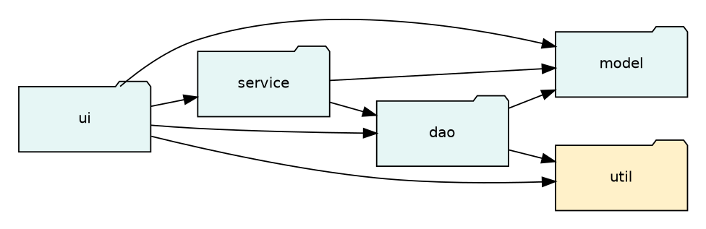
Figure 4 Package diagram
Package | Purpose | Main classes | Public services | FRs
ui | Swing screens and event handling | LoginFrame, DashboardFrame, StudentFrame ... | Screens opened from the dashboard | FR-01 to FR-08
service | Workflow and business rules | ExamService, SeatingGenerator, ShuffleService | generate(), apply(), print() | FR-05, FR-08
model | Domain data | Student, Room, Exam, Seating ... | Getters / setters | FR-02 to FR-07
dao | JDBC persistence | StudentDAO, RoomDAO, ExamDAO, SeatingDAO, UserDAO ... | CRUD and query methods | FR-01 to FR-07
util | Shared helpers | DBConnection, Validation, UI, DateUtil, ComboUtil | getConnection(), text(), date() | All

4.1 Source structure
Project root: smart-exam-seating | src/main/java/com/smartseating/ui | service | model | dao | util | database/schema.sql | pom.xml (Maven, mysql-connector-j) | README.md

4.2 Design conventions
- Classes use PascalCase; methods and variables use camelCase; constants use UPPER_SNAKE_CASE.
- UI classes do not contain SQL; DAO classes do not control Swing components.
- Connections, prepared statements and result sets are closed with try-with-resources.
- Public classes and methods will receive JavaDoc comments before Code Review 2.

5 Database design
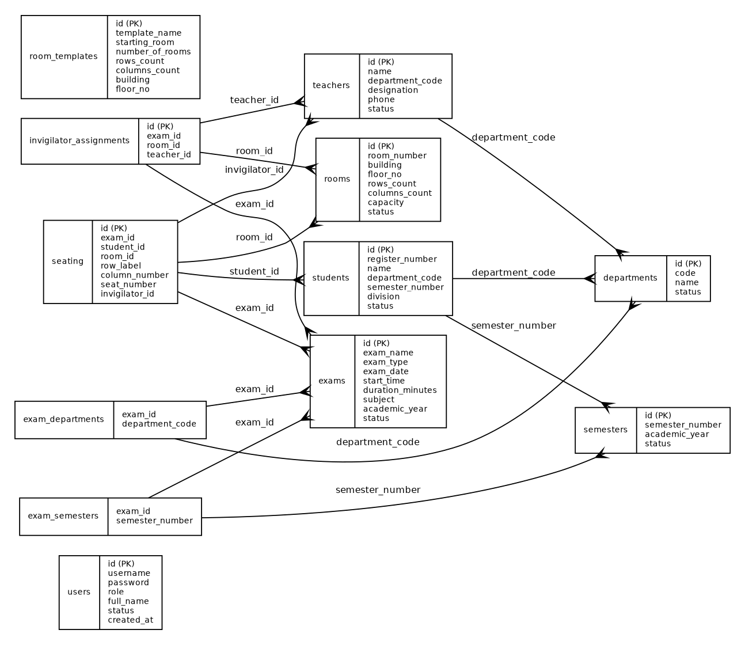
Figure 5 Entity relationship diagram (generated from database/schema.sql)

5.1 Table catalogue
Table | Purpose | Primary key | Foreign keys | FRs
users | Login accounts and roles | id | — | FR-01
departments | Department master data | id | — | FR-03
semesters | Semester master data | id | — | FR-03
students | Student records | id | department_code -> departments, semester_number -> semesters | FR-03
rooms | Rooms with row and column layout | id | — | FR-02
room_templates | Reusable room setup templates | id | — | FR-02
teachers | Teachers / invigilators | id | department_code -> departments | FR-04
exams | Exam sessions | id | — | FR-04
exam_departments | Departments taking an exam | department_code, exam_id | exam_id -> exams, department_code -> departments | FR-04, FR-05
exam_semesters | Semesters taking an exam | exam_id, semester_number | exam_id -> exams, semester_number -> semesters | FR-04, FR-05
seating | Generated seat for each student in an exam | id | exam_id -> exams, student_id -> students, room_id -> rooms, invigilator_id -> teachers | FR-05 to FR-08
invigilator_assignments | Invigilator for each room in an exam | id | exam_id -> exams, room_id -> rooms, teacher_id -> teachers | FR-04

5.2 Detailed table specification
Table: users | Purpose: Login accounts and roles
Column | Data type | PK | FK | Null | Default | Validation or constraint
id | INT | Y | N | N | — | Auto increment
username | VARCHAR(60) | N | N | N | — | Unique
password | VARCHAR(255) | N | N | N | — | —
role | ENUM('ADMIN','TEACHER') | N | N | N | — | —
full_name | VARCHAR(120) | N | N | N | — | —
status | ENUM('ACTIVE','INACTIVE') | N | N | N | 'ACTIVE' | —
created_at | TIMESTAMP | N | N | Y | CURRENT_TIMESTAMP | —

Table: departments | Purpose: Department master data
Column | Data type | PK | FK | Null | Default | Validation or constraint
id | INT | Y | N | N | — | Auto increment
code | VARCHAR(15) | N | N | N | — | Unique
name | VARCHAR(120) | N | N | N | — | Unique
status | ENUM('ACTIVE','INACTIVE') | N | N | N | 'ACTIVE' | —

Table: semesters | Purpose: Semester master data
Column | Data type | PK | FK | Null | Default | Validation or constraint
id | INT | Y | N | N | — | Auto increment
semester_number | VARCHAR(5) | N | N | N | — | Unique
academic_year | VARCHAR(20) | N | N | N | — | —
status | ENUM('ACTIVE','INACTIVE') | N | N | N | 'ACTIVE' | —

Table: students | Purpose: Student records
Column | Data type | PK | FK | Null | Default | Validation or constraint
id | INT | Y | N | N | — | Auto increment
register_number | VARCHAR(30) | N | N | N | — | Unique
name | VARCHAR(120) | N | N | N | — | —
department_code | VARCHAR(15) | N | Y | N | — | FK -> departments(code)
semester_number | VARCHAR(5) | N | Y | N | — | FK -> semesters(semester_number)
division | VARCHAR(10) | N | N | N | — | —
status | ENUM('ACTIVE','INACTIVE') | N | N | N | 'ACTIVE' | —

Table: rooms | Purpose: Rooms with row and column layout
Column | Data type | PK | FK | Null | Default | Validation or constraint
id | INT | Y | N | N | — | Auto increment
room_number | VARCHAR(20) | N | N | N | — | Unique
building | VARCHAR(100) | N | N | N | — | —
floor_no | INT | N | N | N | — | —
rows_count | INT | N | N | N | — | CHECK capacity = rows x columns
columns_count | INT | N | N | N | — | CHECK capacity = rows x columns
capacity | INT | N | N | N | — | CHECK capacity = rows x columns
status | ENUM('AVAILABLE','UNAVAILABLE') | N | N | N | 'AVAILABLE' | —

Table: room_templates | Purpose: Reusable room setup templates
Column | Data type | PK | FK | Null | Default | Validation or constraint
id | INT | Y | N | N | — | Auto increment
template_name | VARCHAR(100) | N | N | N | — | Unique
starting_room | VARCHAR(20) | N | N | N | — | —
number_of_rooms | INT | N | N | N | — | —
rows_count | INT | N | N | N | — | CHECK capacity = rows x columns
columns_count | INT | N | N | N | — | CHECK capacity = rows x columns
building | VARCHAR(100) | N | N | N | — | —
floor_no | INT | N | N | N | — | —

Table: teachers | Purpose: Teachers / invigilators
Column | Data type | PK | FK | Null | Default | Validation or constraint
id | INT | Y | N | N | — | Auto increment
name | VARCHAR(120) | N | N | N | — | —
department_code | VARCHAR(15) | N | Y | N | — | FK -> departments(code)
designation | VARCHAR(80) | N | N | N | — | —
phone | VARCHAR(25) | N | N | N | — | —
status | ENUM('AVAILABLE','UNAVAILABLE') | N | N | N | 'AVAILABLE' | —

Table: exams | Purpose: Exam sessions
Column | Data type | PK | FK | Null | Default | Validation or constraint
id | INT | Y | N | N | — | Auto increment
exam_name | VARCHAR(160) | N | N | N | — | —
exam_type | ENUM('INTERNAL','EXTERNAL') | N | N | N | — | —
exam_date | DATE | N | N | N | — | —
start_time | TIME | N | N | N | — | —
duration_minutes | INT | N | N | N | — | —
subject | VARCHAR(160) | N | N | N | — | —
academic_year | VARCHAR(20) | N | N | N | — | —
status | ENUM('SCHEDULED','COMPLETED','CANCELLED') | N | N | N | 'SCHEDULED' | —

Table: exam_departments | Purpose: Departments taking an exam
Column | Data type | PK | FK | Null | Default | Validation or constraint
exam_id | INT | Y | Y | N | — | FK -> exams(id) ON DELETE CASCADE
department_code | VARCHAR(15) | Y | Y | N | — | FK -> departments(code)

Table: exam_semesters | Purpose: Semesters taking an exam
Column | Data type | PK | FK | Null | Default | Validation or constraint
exam_id | INT | Y | Y | N | — | FK -> exams(id) ON DELETE CASCADE
semester_number | VARCHAR(5) | Y | Y | N | — | FK -> semesters(semester_number)

Table: seating | Purpose: Generated seat for each student in an exam
Column | Data type | PK | FK | Null | Default | Validation or constraint
id | INT | Y | N | N | — | Auto increment
exam_id | INT | N | Y | N | — | Unique key (exam_id,room_id,row_label,column_number); Unique key (exam_id,student_id); FK -> exams(id) ON DELETE CASCADE
student_id | INT | N | Y | N | — | Unique key (exam_id,student_id); FK -> students(id)
room_id | INT | N | Y | N | — | Unique key (exam_id,room_id,row_label,column_number); FK -> rooms(id)
row_label | VARCHAR(5) | N | N | N | — | Unique key (exam_id,room_id,row_label,column_number)
column_number | INT | N | N | N | — | Unique key (exam_id,room_id,row_label,column_number)
seat_number | VARCHAR(10) | N | N | N | — | —
invigilator_id | INT | N | Y | Y | — | FK -> teachers(id) ON DELETE SET NULL

Table: invigilator_assignments | Purpose: Invigilator for each room in an exam
Column | Data type | PK | FK | Null | Default | Validation or constraint
id | INT | Y | N | N | — | Auto increment
exam_id | INT | N | Y | N | — | Unique key (exam_id,room_id); Unique key (exam_id,teacher_id); FK -> exams(id) ON DELETE CASCADE
room_id | INT | N | Y | N | — | Unique key (exam_id,room_id); FK -> rooms(id) ON DELETE CASCADE
teacher_id | INT | N | Y | N | — | Unique key (exam_id,teacher_id); FK -> teachers(id)

6 Swing user interface design
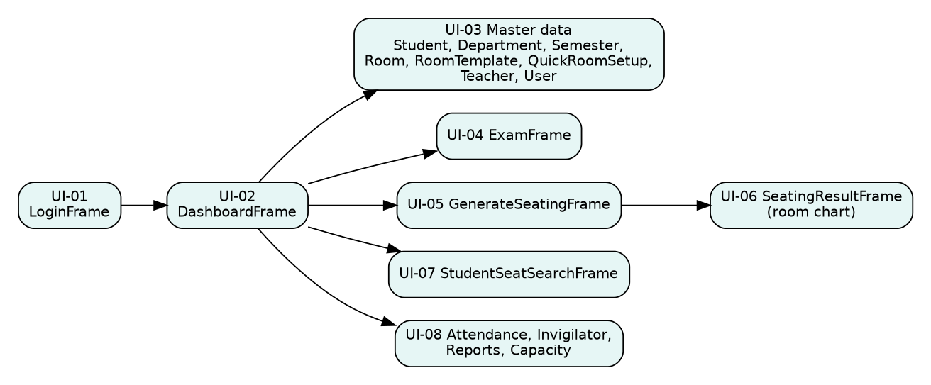
Figure 6 Screen navigation map
Screen | User and purpose | Main components | Actions | FRs
UI-01 LoginFrame | All users: sign in | Username, password, Login button | Authenticate, open dashboard | FR-01
UI-02 DashboardFrame | All users: navigate; see counts | Menu buttons, statistics | Open any screen, logout | FR-01
UI-03 Master data screens | Admin: manage students, departments, semesters, rooms, teachers, users | Form fields, JComboBox, JTable, search box | Add, update, delete, clear, print | FR-02, FR-03
UI-04 ExamFrame | Admin: create exams | Exam form, department and semester lists, JTable | Add, update, delete | FR-04
UI-05 GenerateSeatingFrame | Admin: generate plan | Exam, shuffle and room selection | Generate, regenerate, clear | FR-05
UI-06 SeatingResultFrame | Admin / Teacher: view room chart | Chart text, summary, tabs | Print | FR-06, FR-08
UI-07 StudentSeatSearchFrame | Student / help desk: find seat | Register field, result area | Search, print | FR-07
UI-08 Attendance, Invigilator, Reports | Admin / Teacher: sheets and reports | Exam selector, output area | Show, print | FR-08

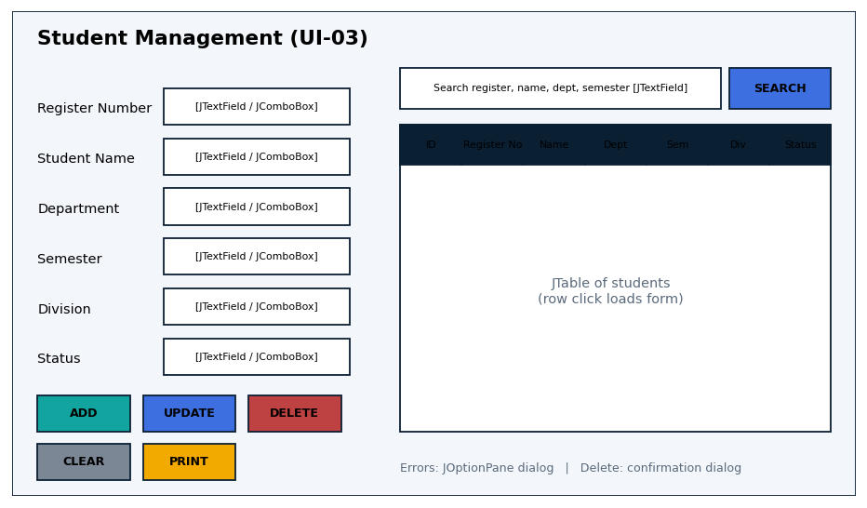
Figure 7 Key Swing screen wireframe (Student Management)

6.1 User feedback and states
- Validation messages: shown in a JOptionPane error dialog naming the field, e.g. 'Register number is required.'
- Confirmation messages: deleting a record and regenerating an existing seating plan ask for confirmation first.
- Empty states: tables refresh after every action; a search with no match shows an empty table or a 'not found' message.
- Roles: Teacher accounts have Add, Update and Delete disabled on master-data screens.

7 Interaction and sequence design
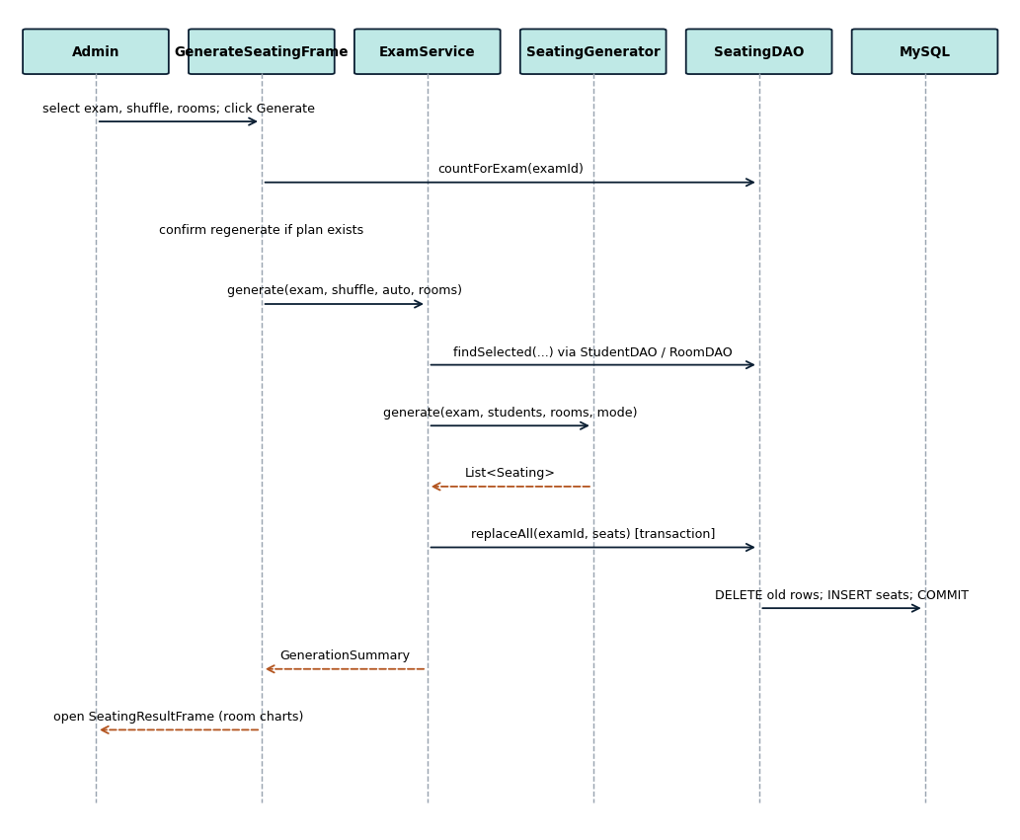
Figure 8 Sequence diagram for UC-05 Generate seating plan
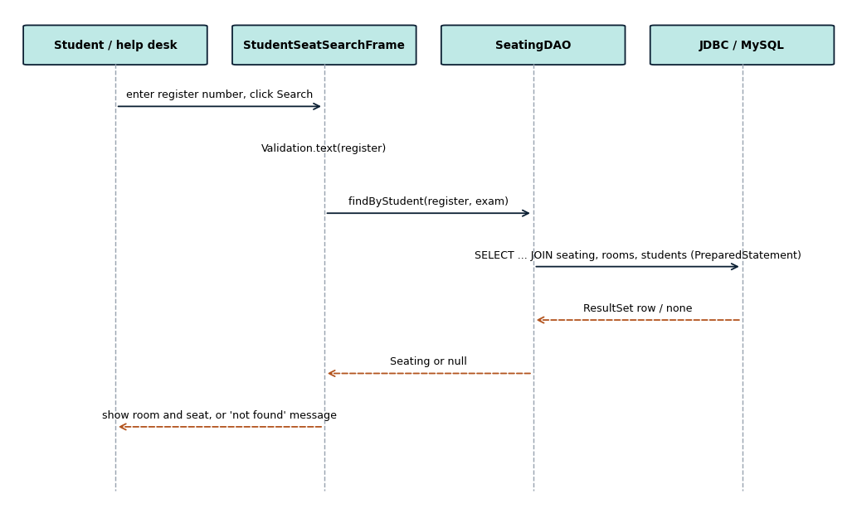
Figure 9 Sequence diagram for UC-07 Search seat
Workflow | Initiating screen | Service method | DAO method | Success result | Error result
UC-05 | UI-05 | ExamService.generate() | SeatingDAO.replaceAll() | Seats saved; result screen opens | Message dialog; transaction rolled back
UC-07 | UI-07 | — | SeatingDAO.findByStudent() | Room and seat displayed | 'Not found' or validation message

8 Validation, exception handling and data integrity

8.1 Validation design
Input or rule | Validation | Where enforced | User message | FR
Required text fields | Not empty | UI via Validation.text() | '<Field> is required.' | FR-02 to FR-04
Numbers (rows, columns, duration) | Positive whole number | UI via Validation.positive() | '<Field> must be a positive whole number.' | FR-02
Exam date / time | yyyy-MM-dd; HH:mm | UI via Validation.date() / time() | 'Exam date must use yyyy-MM-dd.' | FR-04
Duplicate register number / room number | Unique | Database UNIQUE key | Database error dialog | FR-02, FR-03
Room capacity | capacity = rows x columns | Database CHECK | Database error dialog | FR-02
Enough room capacity | Capacity >= students | Service (RoomAllocationService) | 'Selected room capacity is insufficient ...' | FR-05
No double-booked seat | Unique (exam, room, row, column) and (exam, student) | Database | Operation rejected and rolled back | FR-05

8.2 Exception handling
Failure | Detection point | Handling and recovery | Message or log
Invalid input | UI / Validation | IllegalArgumentException caught in the frame; operation stopped, entered data kept | Meaningful dialog
Database unavailable | DBConnection / DAO | SQLException caught; login screen reports 'Database connection failed' | User message
SQL operation fails | DAO | Rollback in SeatingDAO; resources closed by try-with-resources | User message
Unexpected error | Frame event handler | Caught by catch (Exception) in the handler; no crash | Generic dialog

8.3 JDBC and data integrity decisions
- PreparedStatement with ? parameters is used for all variable values.
- SeatingDAO saves a generated plan in one transaction (commit or rollback).
- Primary keys, foreign keys, UNIQUE and CHECK constraints are defined in schema.sql.
- try-with-resources closes connections, statements and result sets.
- Credentials come from system properties or environment variables (SMART_SEATING_DB_URL, _USER, _PASSWORD), not from the UI.

8.4 Additional considerations
Authentication and access control: users are authenticated against the users table; ADMIN and TEACHER roles restrict destructive actions. Known limitation: passwords are stored as plain text (DC-05); SHA-256 hashing is the planned improvement.

9 Design traceability
FR | Use case | Module | Class or method | Screen | DB table | Verification
FR-01 | UC-01 | M1 Login | LoginFrame.login(), UserDAO.authenticate() | UI-01 | users | TC-01, TC-02
FR-02 | UC-03 | M2 Master data | RoomFrame, RoomDAO, QuickRoomSetupFrame | UI-03 | rooms, room_templates | TC-03, TC-04
FR-03 | UC-02 | M2 Master data | StudentFrame, StudentDAO (CSV: DC-01) | UI-03 | students | TC-05, TC-06
FR-04 | UC-04 | M2 Master data | ExamFrame, ExamDAO, InvigilatorDAO | UI-04 | exams, invigilator_assignments | TC-07
FR-05 | UC-05 | M3 Allocation | ExamService.generate(), SeatingGenerator, ShuffleService.mix() | UI-05 | seating | TC-08, TC-09, TC-10
FR-06 | UC-06 | M3 Allocation | SeatingResultFrame.roomChart() (swap: DC-02) | UI-06 | seating | TC-11
FR-07 | UC-07 | M4 Search | StudentSeatSearchFrame, SeatingDAO.findByStudent() | UI-07 | seating | TC-12, TC-13
FR-08 | UC-08 | M4 Reports | AttendanceFrame, ReportsFrame, PrintService | UI-08 | seating | TC-14, TC-15

9.1 Important design decisions
ID | Decision | Reason and alternatives considered | Impact
DD-01 | Layered architecture with DAO pattern | Keeps SQL out of screens; alternative was SQL inside Swing handlers | Easier to test and explain; more classes
DD-02 | Rooms as rows x columns with a CHECK constraint | Simple seat grid; alternative was a seats-per-bench field | Capacity is always consistent
DD-03 | Department Mixing by round-robin | Separates branches without checking each neighbour; alternative was an adjacency solver | Simple and fast; separation is approximate

9.2 Design risks
Risk | Likelihood | Impact | Mitigation | Owner
Database unreachable during demo | M | H | Test connection before review; clear error message | Team Lead
Seating regenerated by mistake | M | M | Confirmation dialog before regenerating | Antony
Plain-text passwords | H | M | Planned hashing (DC-05) | Lijo

10 Implementation readiness

10.1 Team responsibility plan
Member | Primary responsibility | Classes or modules | Integration responsibility | Target date
Antony Zavior K (Lead) | Seat allocation and exams | ExamService, SeatingGenerator, ShuffleService, SeatingDAO, GenerateSeatingFrame, ExamFrame | Integration and final review | ____
Lijo P Thomas | Login, users, students, departments, semesters | LoginFrame, DashboardFrame, UserDAO, StudentFrame, StudentDAO, Validation, DBConnection | Database setup and build | ____
Milind Krishnan | Rooms, search and reports | RoomFrame, QuickRoomSetupFrame, StudentSeatSearchFrame, AttendanceFrame, ReportsFrame, PrintService | Test data and report checks | ____

10.2 Design review checklist
[ ] The design implements the approved requirements and scope (changes recorded in 1.1).
[ ] Use cases, classes, packages, tables and screens use consistent names.
[ ] The design separates Swing UI, business logic and JDBC data access responsibilities.
[ ] Database keys, relationships, validation and error handling are defined.
[ ] Each functional requirement is traceable to design elements and a planned verification.
[ ] The team has recorded current HackerRank Java progress for every member.

10.3 Review outcome
Item | Entry
Decision | [Approved / Approved with changes / Revise and resubmit]
Changes required
Team Lead | Antony Zavior K Signature: ______________
Reviewer | ______________ Signature: ______________
Date | ______________

Next milestone: Code Review 1 - Basic Java and OOP with emphasis on coding standards. Carry forward the updated HackerRank progress table.

Appendix A HackerRank evidence
A Antony Zavior K: https://www.hackerrank.com/profile/haxey61790
A Lijo P Thomas: https://www.hackerrank.com/profile/lijot707
A Milind Krishnan: (add profile link or screenshot)
Insert a current screenshot of each profile here showing the name and Java star level.

